ERIENCE

For any potential employer please find attached my sample visualization made **with Power BI** and **SQL Server**.  
  
The dummy database was obtained from **Adventure Works** composed of 15 Dimensional Tables and 16 Fact Tables.  
<https://docs.microsoft.com/en-us/sql/samples/adventureworks-install-configure?view=sql-server-ver15&tabs=tsql>  
  
The Visualizations represent the Contribution Margin of the organization defined as: (selling Price – Variable Cost) and intends provide an overview of profitability vs sales.

SAMPLE POWER BI APP

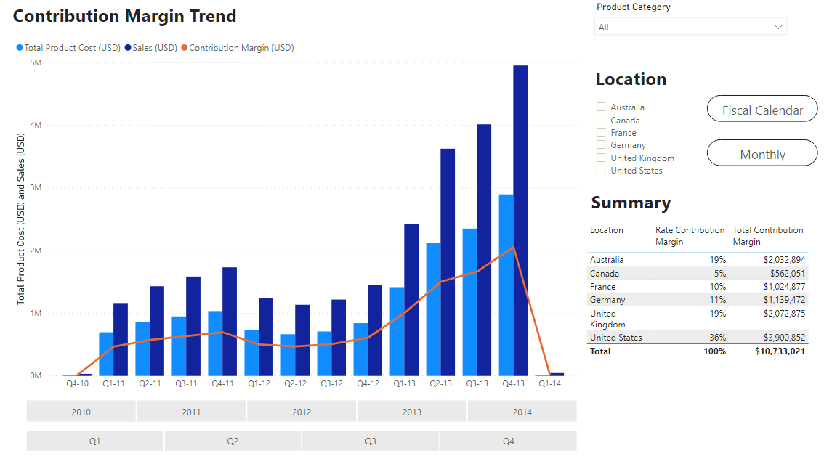

The visualization can be slice in location and products, and the **Summary** section provides the **Rate Contribution Margin** for each **Location**.

The trend is available in **Fiscal** and **Gregorian calendar**, and the chart may be slice in **years**, **months** and **quarters** which makes comparison of quarters and month between years insightful and easy for the user.

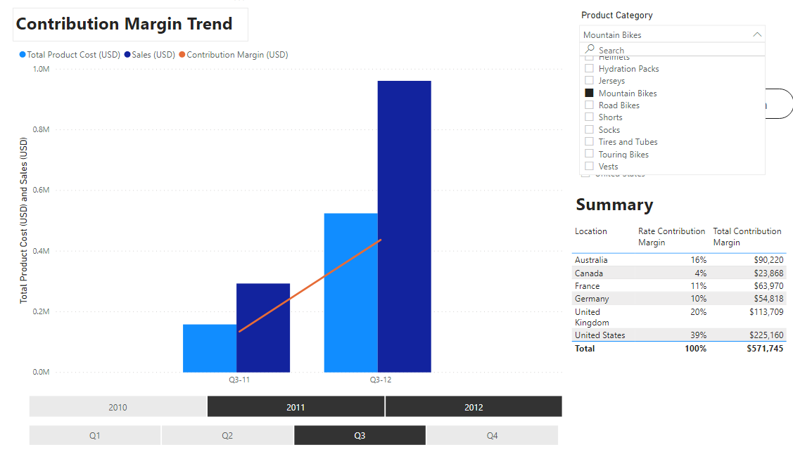

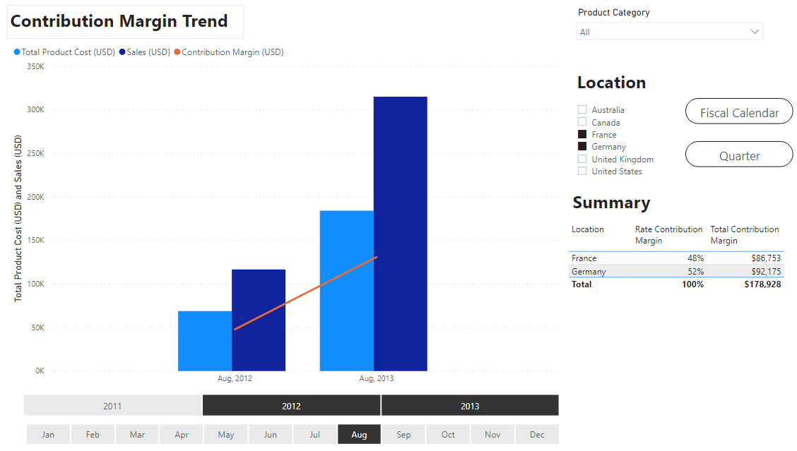

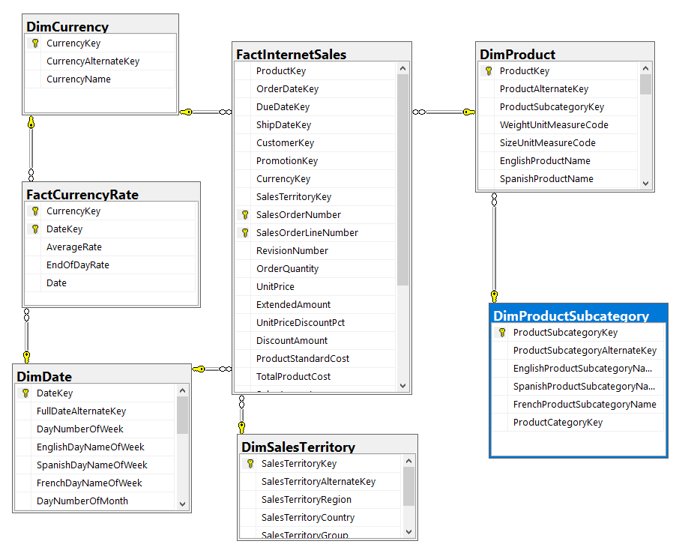

TABLES INVOLVE DIAGRAM

Adventure Works has a Snowflake schema therefore some of the dimension tables like product are normalized.  
  
**FactCurrency** Rate used to convert all currencies to (USD)  
**DimDate** is the Adventure Works Calendar, I used this table to generate a Custom Calendar View which allow me to provide the detailed level with easy access.   
**DimSalesTerritory** used to obtain the locations.  
**DimProductSubcategory** used generate the list of products for the slicer.

**Custom Calendar VIEW used to build the slicers and trend.**

SQL VIEWs USED FOR THE VISUALIZATIONS

SELECT *,

-- These string columns can be used as axis in the Trend Charts

CONCAT ( Fiscal_Quarter_Name, '-', RIGHT(FiscalYear, 2) ) AS 'Fiscal Year-Quarter', -- Sample outupt: Q3-05 (Fiscal starts in Q3)

CONCAT ( Gregorian_Quarter_Name, '-', RIGHT(CalendarYear, 2) ) AS 'Gregorian Year Quarter', -- Sample outupt: Q1-05 (Gregorian starts in Q1)

-- These IDS can be used to OrderBy trend charts.

--- Sample output = 20053 , 20054 , 20061 , 20062 ....

CAST( CONCAT(FiscalYear, FiscalQuarter) AS int) AS 'ID_Fiscal_Year_QUARTER',

--- Sample output = 20052, 20061

CAST( CONCAT(FiscalYear, FiscalSemester) AS int) AS 'ID_Fiscal_Year_Semester',

--- Sample output = 200501, 200502, 200503, 200504

CONCAT (

CalendarYear,

REPLICATE('0',2-LEN(RTRIM(CalendarQuarter))) + RTRIM(CalendarQuarter)

) AS ID_Gregorian_Year_QUARTER,

--- Sample output = 200501

CONCAT (

CalendarYear,

REPLICATE('0',2-LEN(RTRIM(MonthNumberOfYear))) + RTRIM(MonthNumberOfYear)

) AS ID_Gregorian_Year_Month,

--- Sample output = 20050101

CONCAT (

CalendarYear,

REPLICATE('0',2-LEN(RTRIM(DayNumberOfMonth))) + RTRIM(DayNumberOfMonth) ,

REPLICATE('0',2-LEN(RTRIM(WeekNumberOfYear))) + RTRIM(WeekNumberOfYear)

) AS ID_Gregorian_Year_Month_Week,

--- Sample output = 200501001

CONCAT (

CalendarYear,

REPLICATE('0',2-LEN(RTRIM(DayNumberOfMonth))) + RTRIM(DayNumberOfMonth) ,

REPLICATE('0',3-LEN(RTRIM(MonthNumberOfYear))) + RTRIM(MonthNumberOfYear)

) AS ID_Gregorian_Year_Month_Day

FROM

(

SELECT *,

FORMAT ( FullDateAlternateKey, 'MMM, yyyy') AS 'Gregorian Year-Month', -- Sample outupt: Dec, 2010

--For Fiscal Quarters

CASE

WHEN FiscalQuarter = 1

THEN 'Q1'

WHEN FiscalQuarter = 2

THEN 'Q2'

WHEN FiscalQuarter = 3

THEN 'Q3'

WHEN FiscalQuarter = 4

THEN 'Q4'

END AS Fiscal_Quarter_Name,

--For Gregorian Quarters

CASE

WHEN CalendarQuarter = 1

THEN 'Q1'

WHEN CalendarQuarter = 2

THEN 'Q2'

WHEN CalendarQuarter = 3

THEN 'Q3'

WHEN CalendarQuarter = 4

THEN 'Q4'

END AS Gregorian_Quarter_Name

FROM DimDate

) AS temp_Q

**Sales/Contribution Margin VIEW build to host the data.**

SELECT

-- Trend Values

fIS.SalesAmount * tempC.AverageRate AS 'Sales (USD)',

fIS.TotalProductCost * tempC.AverageRate AS 'Total Product Cost (USD)',

(fIS.SalesAmount * tempC.AverageRate) - (fIS.TotalProductCost * tempC.AverageRate) AS 'Contribution Margin (USD)',

-- Slice and group by on the Visualization

dimST.SalesTerritoryCountry,

-- Trend Axis will depend of these columns

viewD.[Gregorian Year Quarter],

viewD.[Fiscal Year-Quarter],

viewD.[Gregorian Year-Month],

-- The following columns are used as slice in the visualization.

CAST(viewD.FiscalYear AS VARCHAR(4)) AS 'Fiscal Year STR',

CAST(viewD.CalendarYear AS VARCHAR(4)) AS 'Gregorian Year STR',

LEFT(viewD.EnglishMonthName, 3) AS Month_STR,

viewD.Fiscal_Quarter_Name AS 'Fiscal Quarter STR',

viewD.Gregorian_Quarter_Name AS 'Gregorian Quarter STR',

-- Trend chart will be order by these ID columns.  
 -- Sample output INT: 1,2,....,12

viewD.MonthNumberOfYear AS 'ID_Month_Number',

-- Sample output INT: 201102   
 viewD.ID_Fiscal_Year_QUARTER,

-- Sample output INT: 201012

viewD.ID_Gregorian_Year_Month,

-- Sample output INT: 201004

viewD.ID_Gregorian_Year_QUARTER,

-- Product Slicer

dimPC.EnglishProductSubcategoryName

FROM FactInternetSales AS fIS

--Added currency conversion rates ( USD )

INNER JOIN tempCurrencyLookup AS tempC

ON CONCAT(tempC.CurrencyKey,tempC.DateKey) = CONCAT(fIS.CurrencyKey,fIS.OrderDateKey)

--Added dimension Table Sales Territory

LEFT JOIN DimSalesTerritory AS dimST

ON fIS.SalesTerritoryKey = dimST.SalesTerritoryKey

--Added custom calendar View

INNER JOIN vCustomCalendar AS viewD

ON fIS.OrderDateKey = viewD.DateKey

LEFT JOIN DimProduct as dimP

ON FIS.ProductKey = dimP.ProductKey

LEFT JOIN DimProductSubcategory AS dimPC

ON dimP.ProductSubcategoryKey = dimPC.ProductSubcategoryKey